**Name: Sourav Bikash**

**Roll No.:11012338**

**Submission Date:1 3/04/2013 Time:23:59 hrs.**

**Aim of the Problem:**

The first part of the problem generates Van Der Corput sequence using base 2. The next part of the problem focuses in using this to generate halton sequences using base 2 and base 3.

**Part I:**

This question wants us to generate the first 25 members of the VDC sequence of base 2. Then we compare the numbers generated with the linear congruence generator.

**Implementation using R:**

vdc<-function(n){

z<-NULL;

for(i in 1:n)

{

j<-i;s<-0;k<-1;

while(j!=0)

{

s<-s+((j%%2)/(2^(k)));

j<-j%/%2;

k<-k+1;

}

z<-c(z,s);

}

return(z);

}

f<-vdc(1000);

**The following are the first 25 members**

|  |  |  |  |  |
| --- | --- | --- | --- | --- |
| 0.50000 | 0.56250 | 0.31250 | 0.53125 | 0.65625 |
| 0.25000 | 0.93750 | 0.81250 | 0.31250 | 0.40625 |
| 0.75000 | 0.06250 | 0.18750 | 0.28125 | 0.90625 |
| 0.12500 | 0.43750 | 0.6875 | 0.78125 | 0.09375 |
| 0.62500 | 0.37500 | 0.87500 | 0.15625 | 0.59375 |

Then we generate the first 1000 and 100000 members. Then we plot the overlapping points.

We also use the LCG:

**x<-((1597*x)+1)% 244944, u<-u/244944;**

**Then we plot their distribution comparatively:**

**For 1000 samples:**

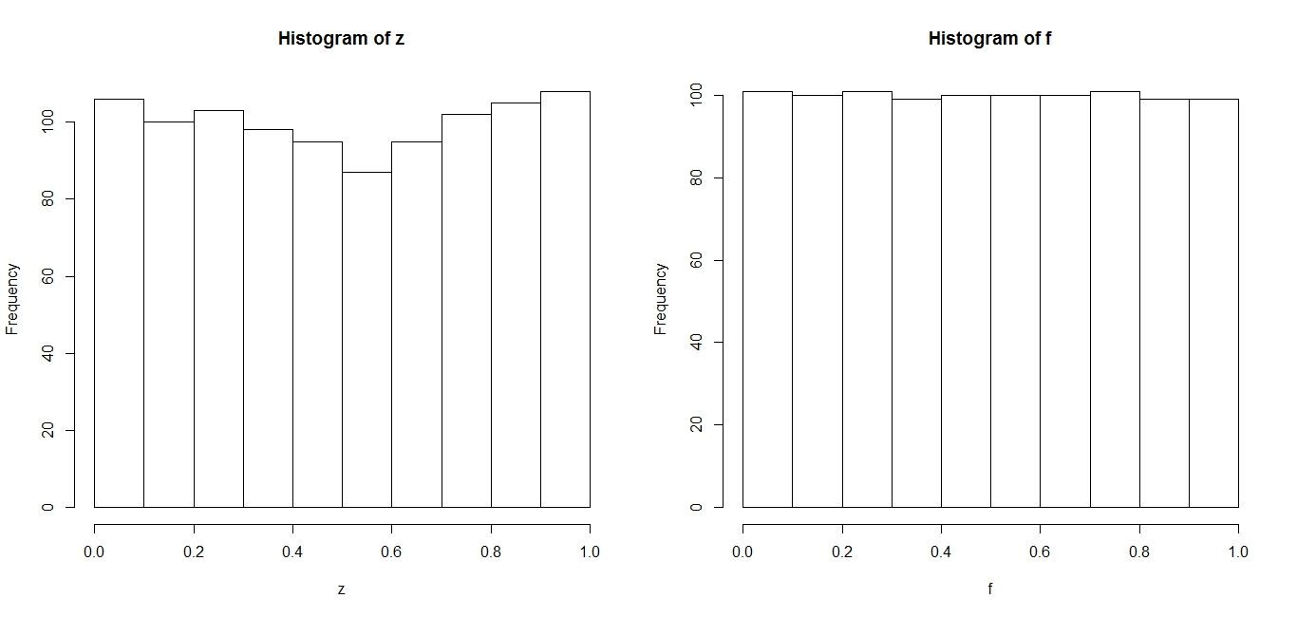

**For 100000 samples:**

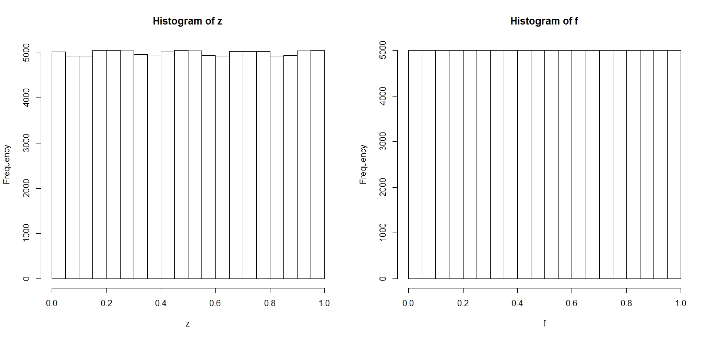

Plot of the overlapping points:

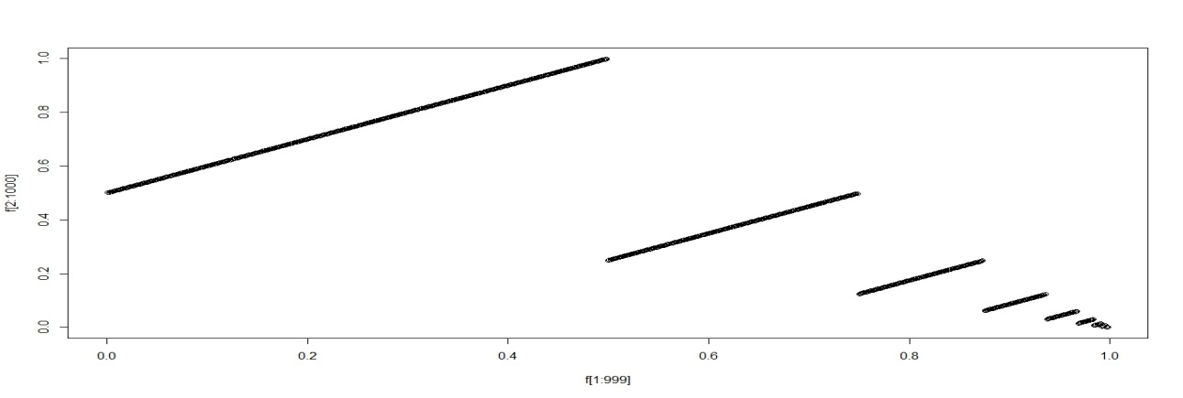

Overall plot of the points of the lcg verses VDC:

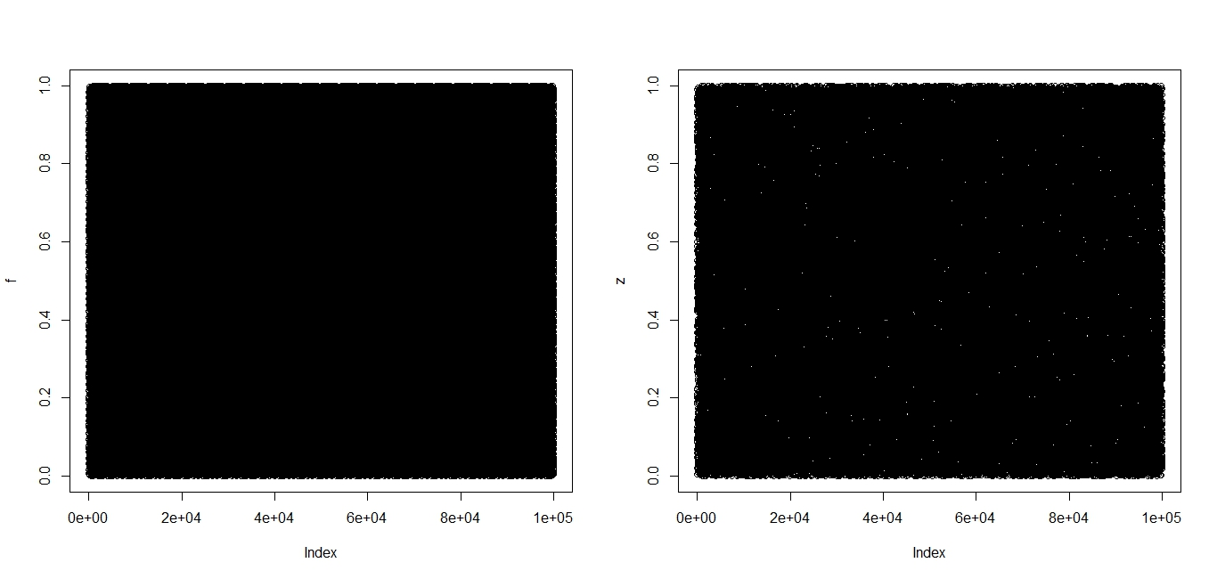

We can see that the VDC sequence is better than the lcg (notice the white spaces in the lcg plot).

**Part II:**

This part generates the Halton sequences.

**Implementation using R:**

vdc2<-function(n){

z<-NULL;

for(i in 1:n)

{

j<-i;s<-0;k<-1;

while(j!=0)

{

s<-s+((j%%2)/(2^(k)));

j<-j%/%2;

k<-k+1;

}

z<-c(z,s);

}

return(z);

}

vdc3<-function(n){

z<-NULL;

for(i in 1:n)

{

j<-i;s<-0;k<-1;

while(j!=0)

{

s<-s+((j%%3)/(3^(k)));

j<-j%/%3;

k<-k+1;

}

z<-c(z,s);

}

return(z);

}

f1<-vdc2(100000);

f2<-vdc3(100000);

**Plot of the sequences:**

For 1000 and 100000 respectively:

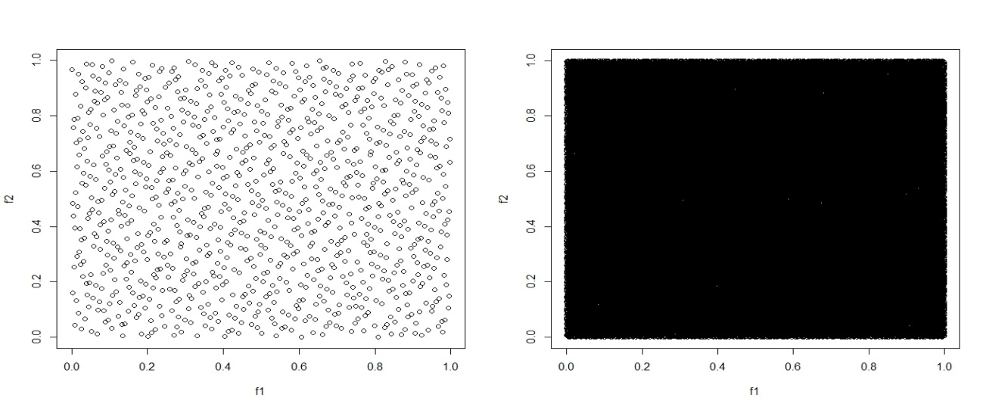

**Observations:**

1. The VDC sequence is better than the LCG.
2. The histogram plot is much more uniformly distributed than that of LCG.
3. The halton sequence gives a fairly uniform distribution of numbers.